Write a C++ program that uses nested for loops to generate a multiplication table from 1 × 1 to 10 × 10. Use the “tab” escape sequence (”\t”) to format the table properly.
Input

// ECE 2305 - Tutorial 16

#include <iostream>
using namespace std;

int main() {
cout << "Multiplication Table (1-10)" << endl;

cout << "\t";
for (int i = 1; i <= 10; i++) {
cout << i << "\t";
}
cout << "\n------------------------------------------------------------------------------------\n";

for (int i = 1; i <= 10; i++) {
cout << i << "|\t";
for (int j = 1; j <= 10; j++) {
cout << (i * j) << "\t";
}
cout << endl;
}

system("pause");
return 0;
}
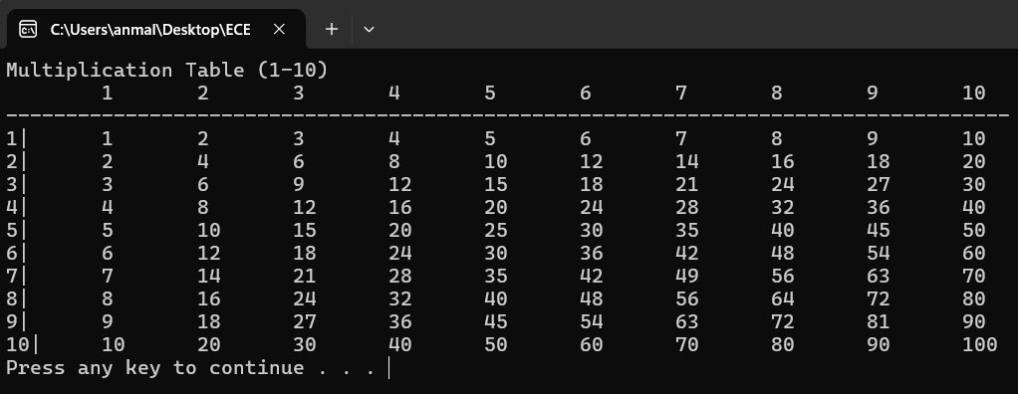
Output

